**B. Studies and Results**

The aim of the lead optimisation project this year has been to bring forward the MERS-CoV/SARS-CoV-2 Mpro protease inhibitor series to give two or more compounds meeting our Target Candidate Profile (TCP) to promote to pre-clinical studies (Project 6). **We are close to achieving all of our TCP goals in one compound with high potency against both SARS-CoV-2 and MERS-CoV in cellular assays, with good mouse pharmacokinetics, an acceptable human predicted dose, and made in sufficient quantity to conduct MERS-CoV in vivo efficacy studies in April.**

Further compounds in the series are being profiled as structurally dissimilar back up compounds.

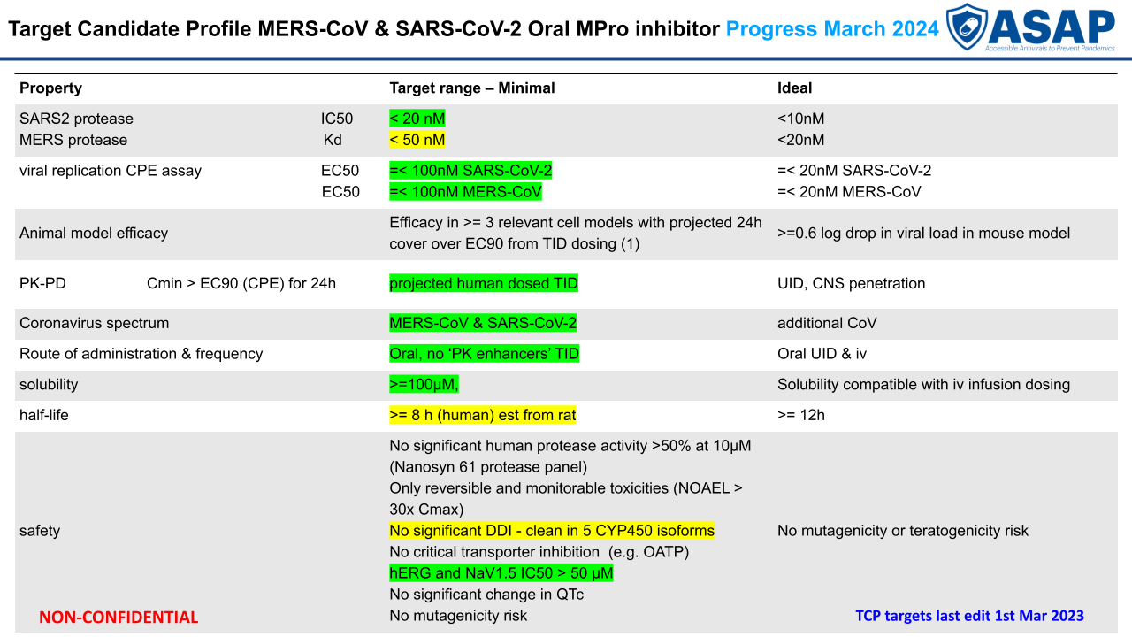

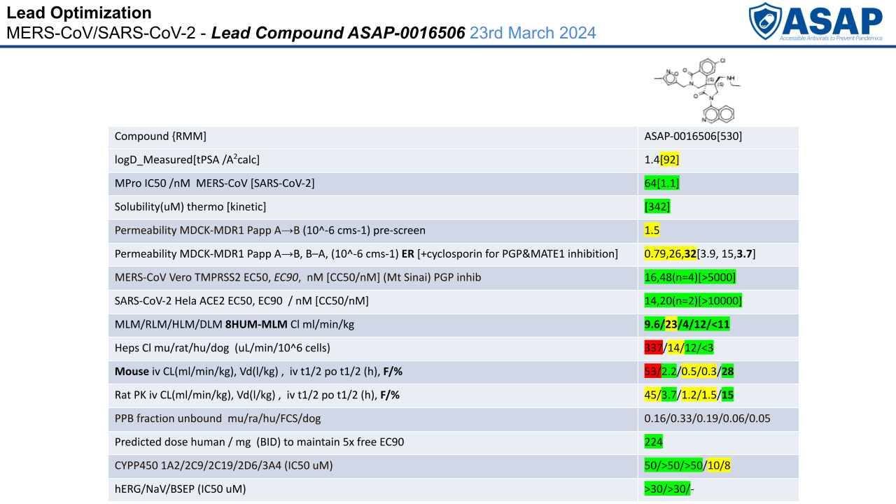

While our non-peptidomimetic, non-covalent Mpro inhibitor series showed good potency against SARS-CoV-2 Mpro, the MERS-CoV Mpro enzyme is more difficult to assay and was much harder to develop a robust protein-ligand crystallography system. This caused some difficulty in rapidly achieving good MERS-CoV Mpro inhibition. Through the **Structural Biology Core’**s efforts—in particular, access to the high throughput crystallization systems—we were able to generate more than 140 MERS-XoC Mpro crystal structures, giving unprecedented understanding of the difference between SARS-CoV-2 and MERS-CoV active sites. The **Biochemical Assay Core** was able to analyze the enzyme kinetics of MERS-CoV MP=pro and establish that our assay system was generating relevant results, which have been used in parallel testing to the SARS-CoV-2 Mpro enzyme assay to establish SAR. Close collaboration between the **Structural Biology Core**, the **Covalent Project 4,** and ourselves enabled us to discover that a compound initially believed to be covalent was actually more potent in MERS-CoV Mpro due to binding in the P1’ sub-pocket. Exploiting this knowledge has led to extremely potent SARS-CoV-2 Mpro inhibition (single digit nM IC50s) simultaneously with good (low double digit) MERS-CoV Mpro inhibition.

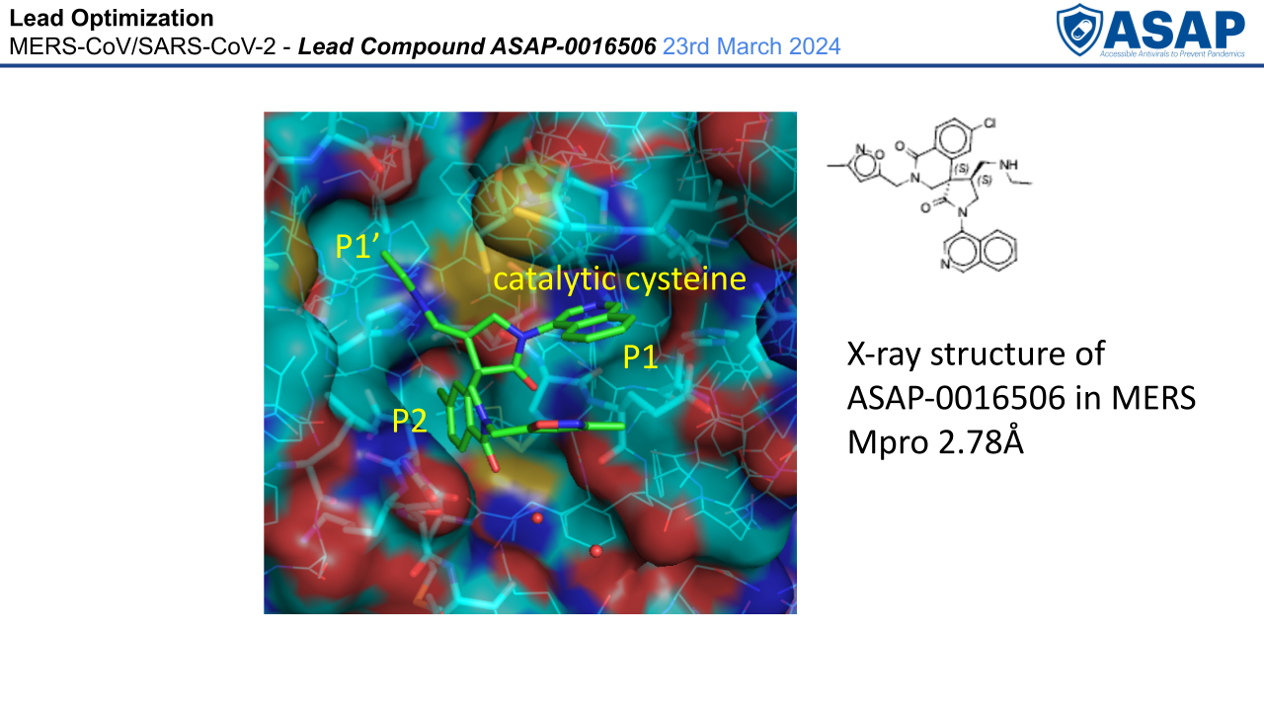

Testing these compounds with the **Antiviral Core’s** HeLa SARS-CoV-2 cell assays showed the compounds are extremely potent cellular inhibitors. Initial delays with the MERS-CoV antiviral testing infrastructure resulted in us generating MERS-CoV cellular data through collaboration with both the MAVDA AViDD Center and NIAID Preclinical Services (PCS), which introduced delays. As soon as the **Antiviral Core** MERS in vitro cellular antiviral activity assay infrastructure came online, we were able to confirm consistent results across all three testing locations for our series and fully support optimisation of the lead compounds. These data confirmed that the unusual enzyme kinetics displayed by MERS-CoV Mpro results in minimal dropoff between enzyme and cell systems, giving compounds with low double digit cellular EC50’s in the MERS-CoV Vero TMPRSS2 system and thus delivering the required TCP potency against cellular assays.

The series has generally low serum protein binding across species, which provides a benefit in having relatively high free drug levels but a challenge to optimize unbound clearance and therefore achieve our pharmacodynamic target of maintaining free drug levels in excess of the free drug EC90 for the duration of dosing. In parallel to screening in the Mpro enzyme assays we have screened against in vitro ADMET assays: mouse and human liver microsomes, an MDCK-MDR1 Apical to Basal permeability assay, kinetic solubility, and logD. We have been able to establish good targets for permeability and enzyme activity to prioritize compounds for the cellular assays and a relationship between the mouse liver microsome assay and in vivo murine clearance. Through the use of AI / machine learning methods developed with **MedChemica,** we have been able to conduct multi parameter optimisation and applied FEP methods with the **Chodera group** to understand where to prioritize chemical synthesis.

Our most promising compounds were initially screened in a mouse iv cassette pharmacokinetic system which confirmed that clearance is mainly driven through hepatic metabolism. Later compounds have been profiled in both mouse iv an po studies to establish bioavailability. The majority of compounds show much higher metabolic stability in human liver microsomes and hepatocytes than mouse liver microsomes and hepatocytes. In order to ensure that we could conduct efficacy studies in mouse we profiled compounds in the leading 8HUM humanized mouse system (where 32 mouse liver metabolic enzymes are replaced with 8 human liver enzymes) and showed that our lead compounds have very low clearance in 8HUM mouse microsomes, mirroring the human data. For our lead compound ASAP-0016506 we have in progress the mouse 8HUM iv and po pharmacokinetic studies to support MERS efficacy studies. In parallel, we conducted ascending dose pharmacokinetic studies in mouse at 100, 300 and 450 mg/kg BID. At these doses, we observed saturation of clearance resulting in excellent cover over the FCS serum corrected MERS-CoV EC90 (36nM) giving the opportunity to use high doses in WT mouse for the MERS-CoV in vivo efficacy studies if the 8HUM system proves problematic.

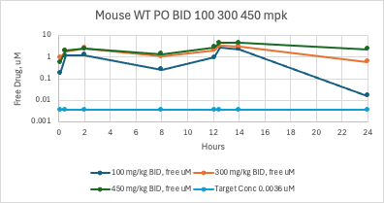

The synthesis of our lead series has received some optimisation with a common intermediate being available in >20 g batches as a single diastereomer. Collaboration with the **Preclinical Development (Project 6)** has resulted in us initiating process development on the common late stage intermediate in advance of final compound selection.

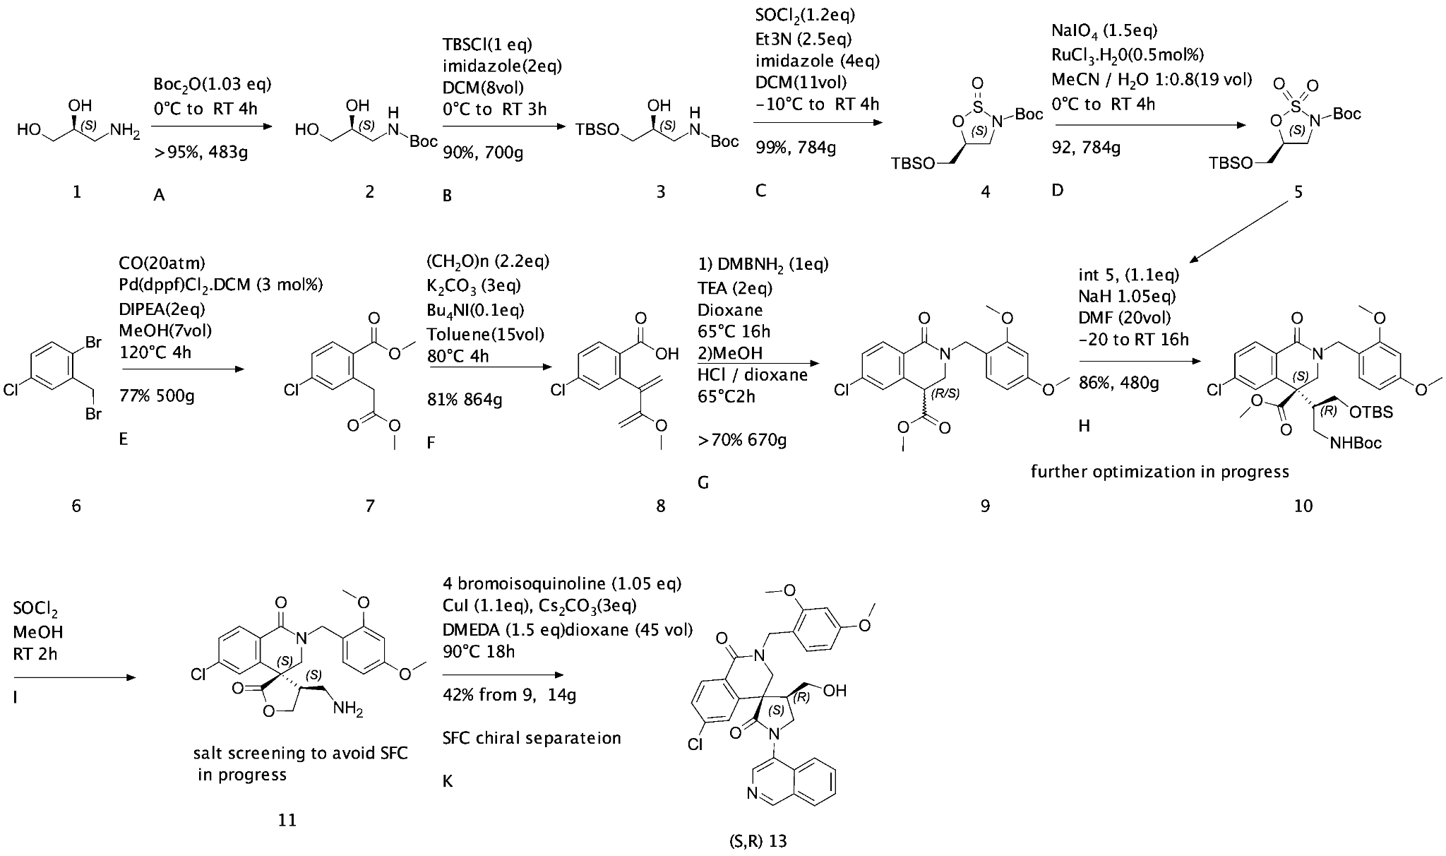

***Figure X:*** *Medicinal chemistry route currently in early process research and development for a flexible diastereomericaly pure intermediate (****S,R******13****).*

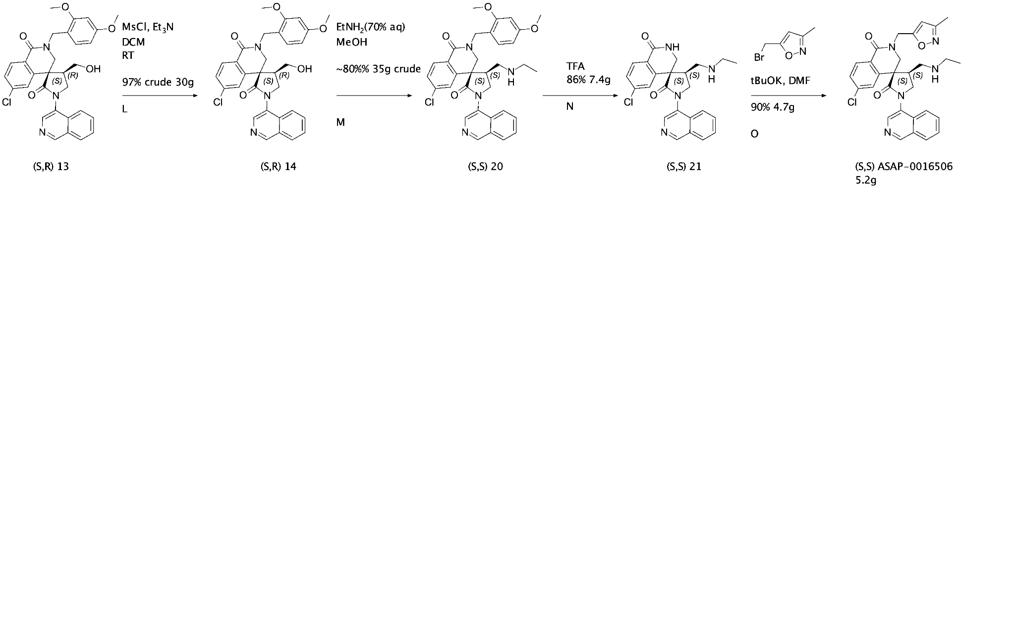

***Figure X****: Route from intermediate (SR 13) to ASAP-0016506.*

Our latest batch of ASAP-0016506 is sufficient to undertake both the efficacy studies and a dog iv & po study. The dog iv & po pharmacokinetic studies are designed to improve our human dose prediction which is currently just based on rat iv & po data with in vitro human and rat ADMET profiling and is planned in conjunction with the NIAID PCS group.

The pre-clinical development project has already instigated further process development on intermediate (***S,R*** **13**) to enable the larger batches of compounds for initial mammalian toxicology evaluation.

**C. Significance**

MERS-CoV, SARS-CoV-1, and SARS-CoV-2 are the three most lethal of the human coronaviridae. MERS-CoV is endemic in dromedary camels, and with ongoing climate change there is an increase in the camel population as a more drought resistant herd animal. With both SARS-CoV-2 and MERS-CoV endemic in multiple high population LMICs (Egypt, Nigeria, Pakistan: total population of 0.5Bn), the risk of a recombination event is high. Currently available Mpro inhibitors have MERS-CoV as a weak point, Therefore a MERS-CoV type lineage C betacoronavirus would not be treatable by existing agents. Our lead series also shows broadly equivalent potency with other tested coronaviridae.

Our Target Product Profile (TPP) is aimed at generating clinical agents for community use as oral therapies with a good safety profile, and minimal drug-drug interactions that could be used to treat patients as well as health workers and close contacts in an outbreak setting in a post-exposure prophylaxis (PEP) mode. Our aim is to contain an epidemic and avoid a pandemic within the first 100 days of a new betacoronaviral threat being realized.

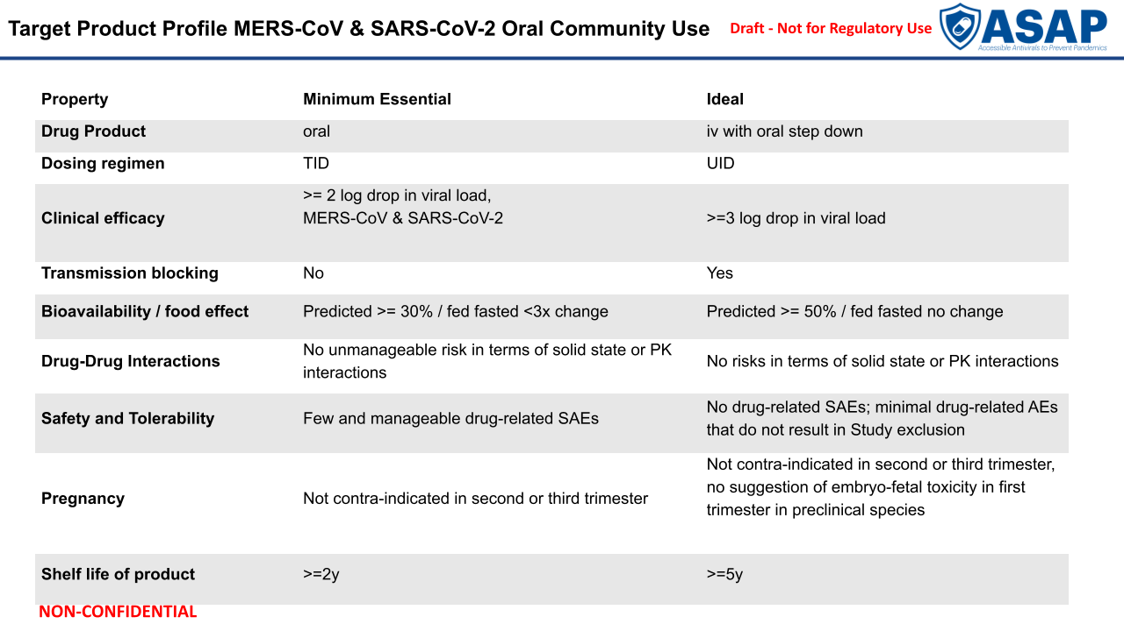

**D. Plans**

* Complete the identification of a minimum of two structurally differentiated optimized MERS-CoV and SARS-COV-2 Mpro inhibitors and transition into pre-clinical development.

* Deliver a short list of compounds for efficacy studies selected from whichever programs complete the hit-to-lead (Project 3) phase. These programs are currently in Project 3:
  + DENV/ZIKV NS2B/3 protease program
  + EV-D68/A71 3C protease program
  + SARS-CoV-2 N protein program
  + SARS-CoV-2 capsid program